Exercise-3 M.Rohith
26-03-2023 3122 21 5001 085

HELLO SERVLET WEB APPLICATION USING TOMCAT SERVER

Aim:

To implement simple hello servlet web application using Apache Tomcat server.

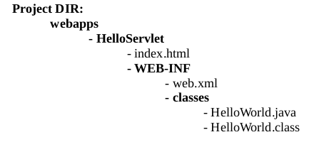

Program code:

index.html

<html>
<head>
<title>My First Web Application</title>
</head>
<body>
<form action="hello" method="get">
<button type="submit">Click Me</button>
</form>
</body>
</html>

web.xml

<web-app>
<servlet>
<servlet-name>HelloWorld</servlet-name>
<servlet-class>HelloWorld</servlet-class>
</servlet>
<servlet-mapping>
<servlet-name>HelloWorld</servlet-name>
<url-pattern>/hello</url-pattern>
</servlet-mapping>
<welcome-file-list>
<welcome-file>index.html</welcome-file>
</welcome-file-list>
</web-app>

HelloWorld.java

import java.io.*;
import javax.servlet.*;
import javax.servlet.http.*;

public class HelloWorld extends HttpServlet {
public void doGet(HttpServletRequest request,HttpServletResponse response) throws IOException, ServletException {
response.setContentType("text/html");
PrintWriter out = response.getWriter();
out.println("<html>");
out.println("<head>");
out.println("<title>Hello World! </title>");
out.println("</head>");
out.println("<body>");
out.println("<h1>Hello Java servlet!</h1>");
out.println("</body>");
out.println("</html>");
}
}

Output:

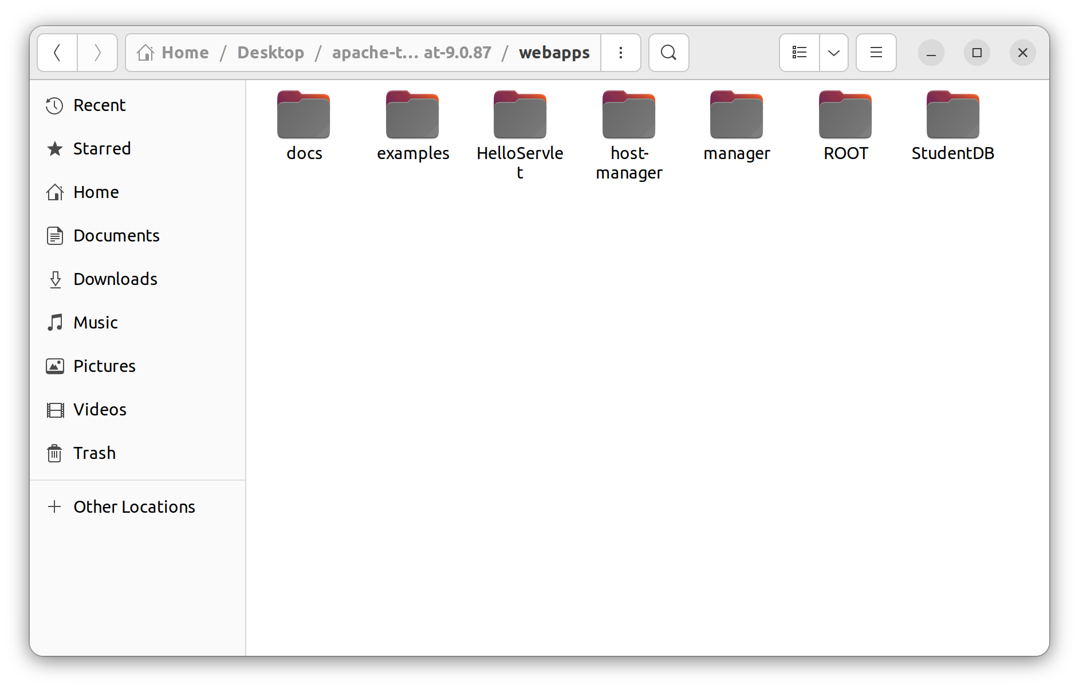
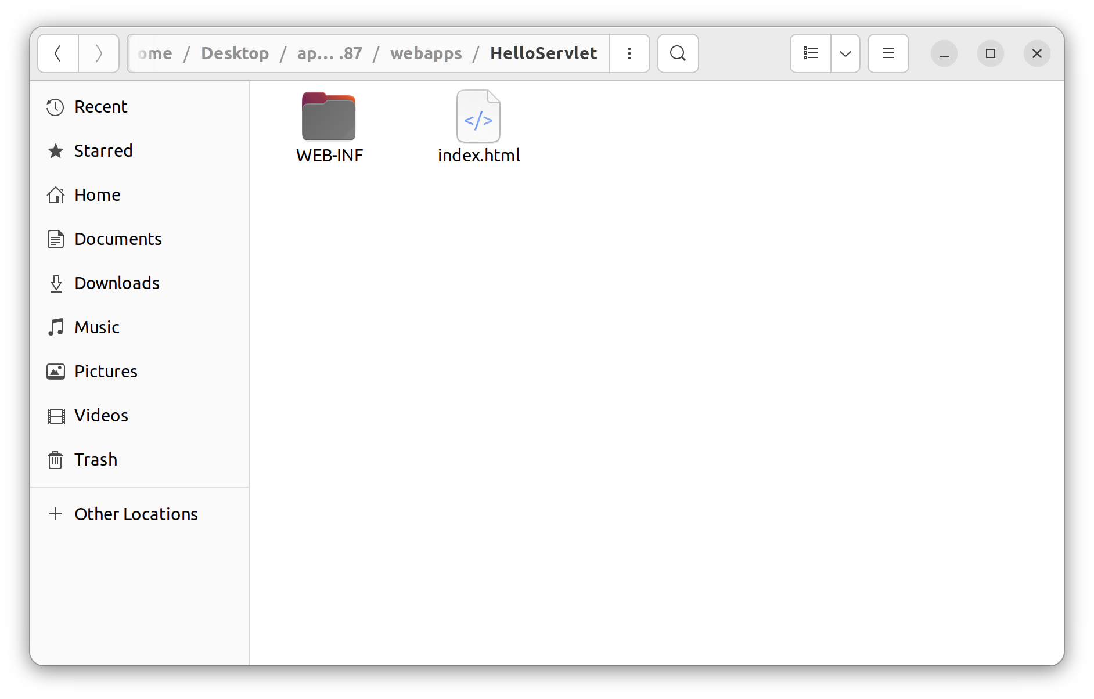
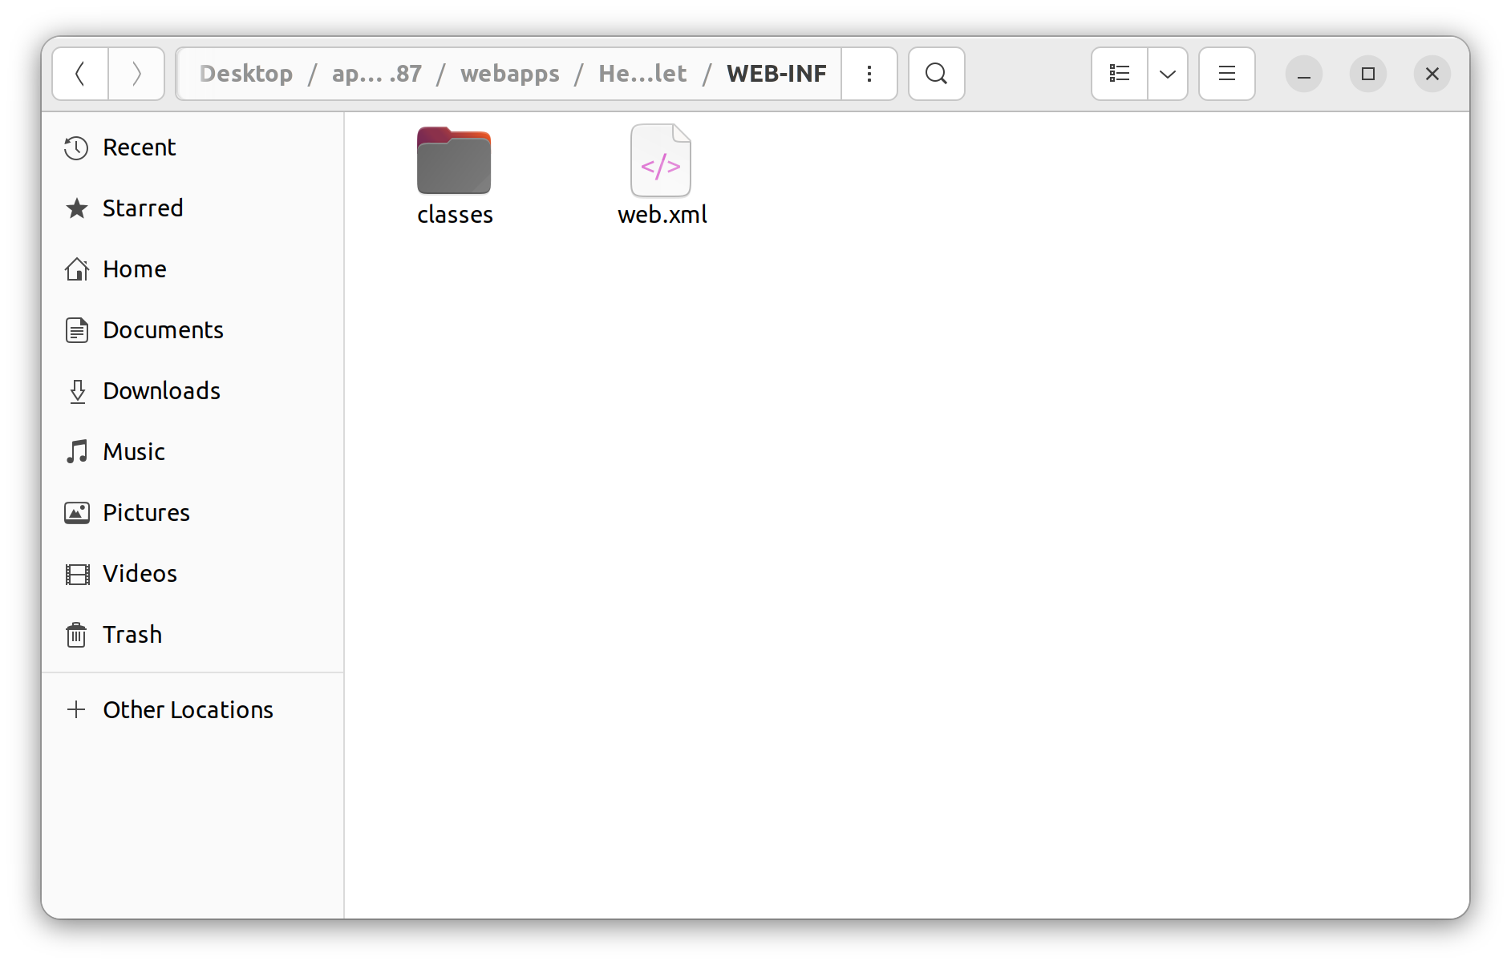
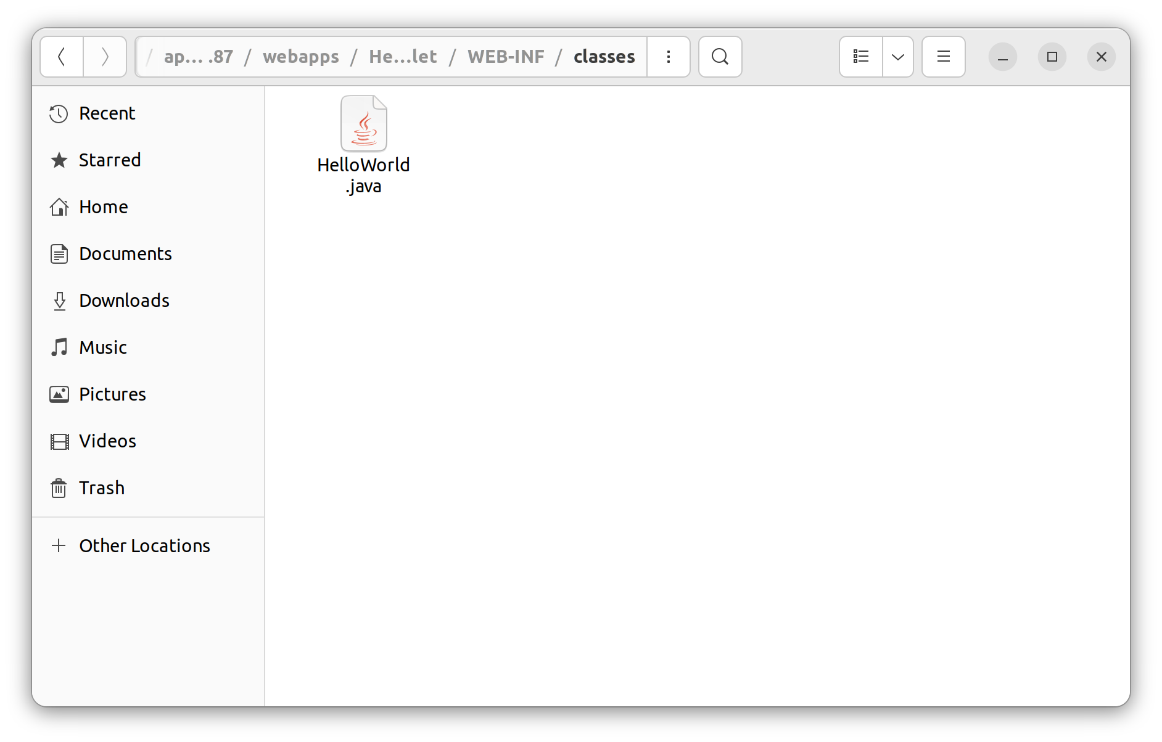
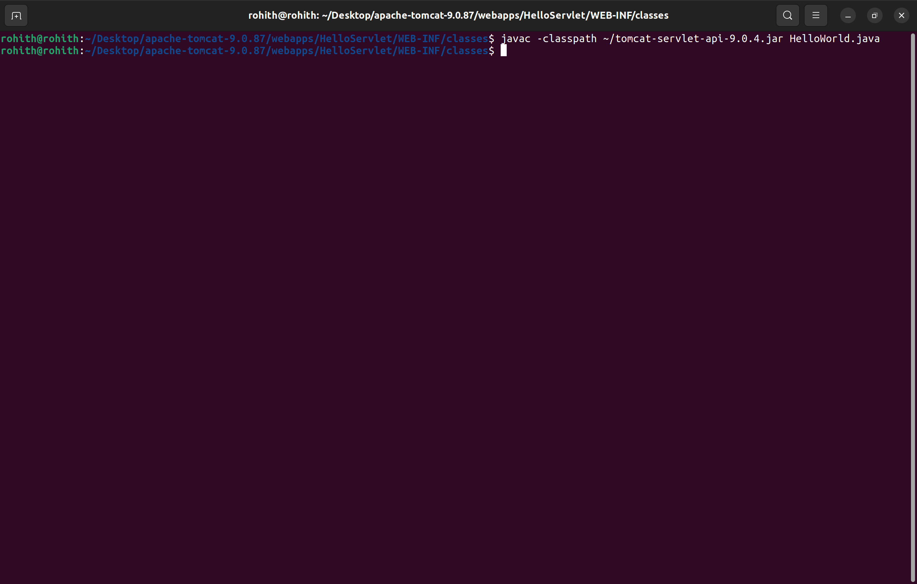
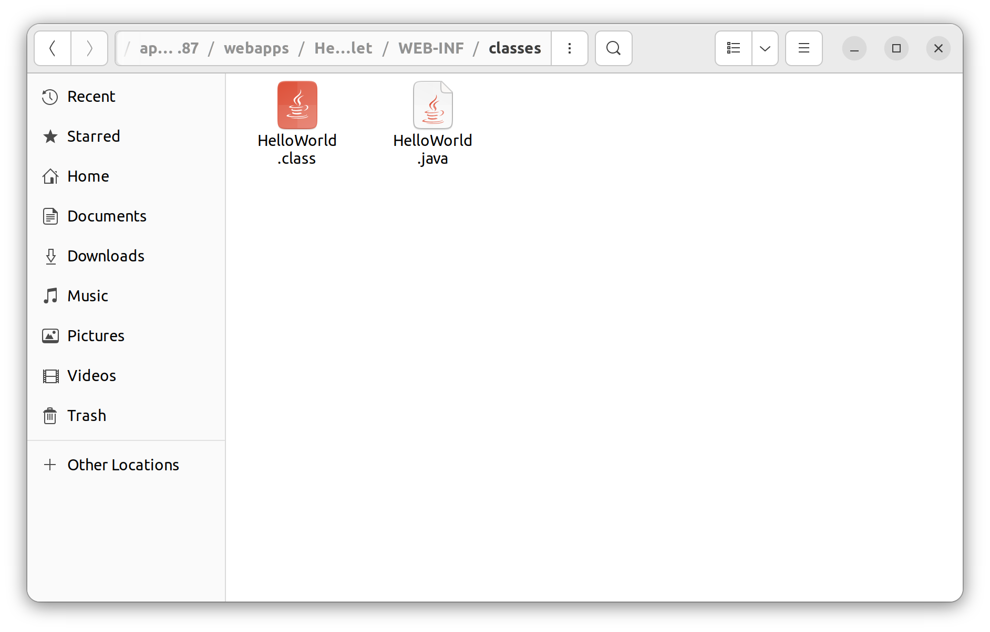
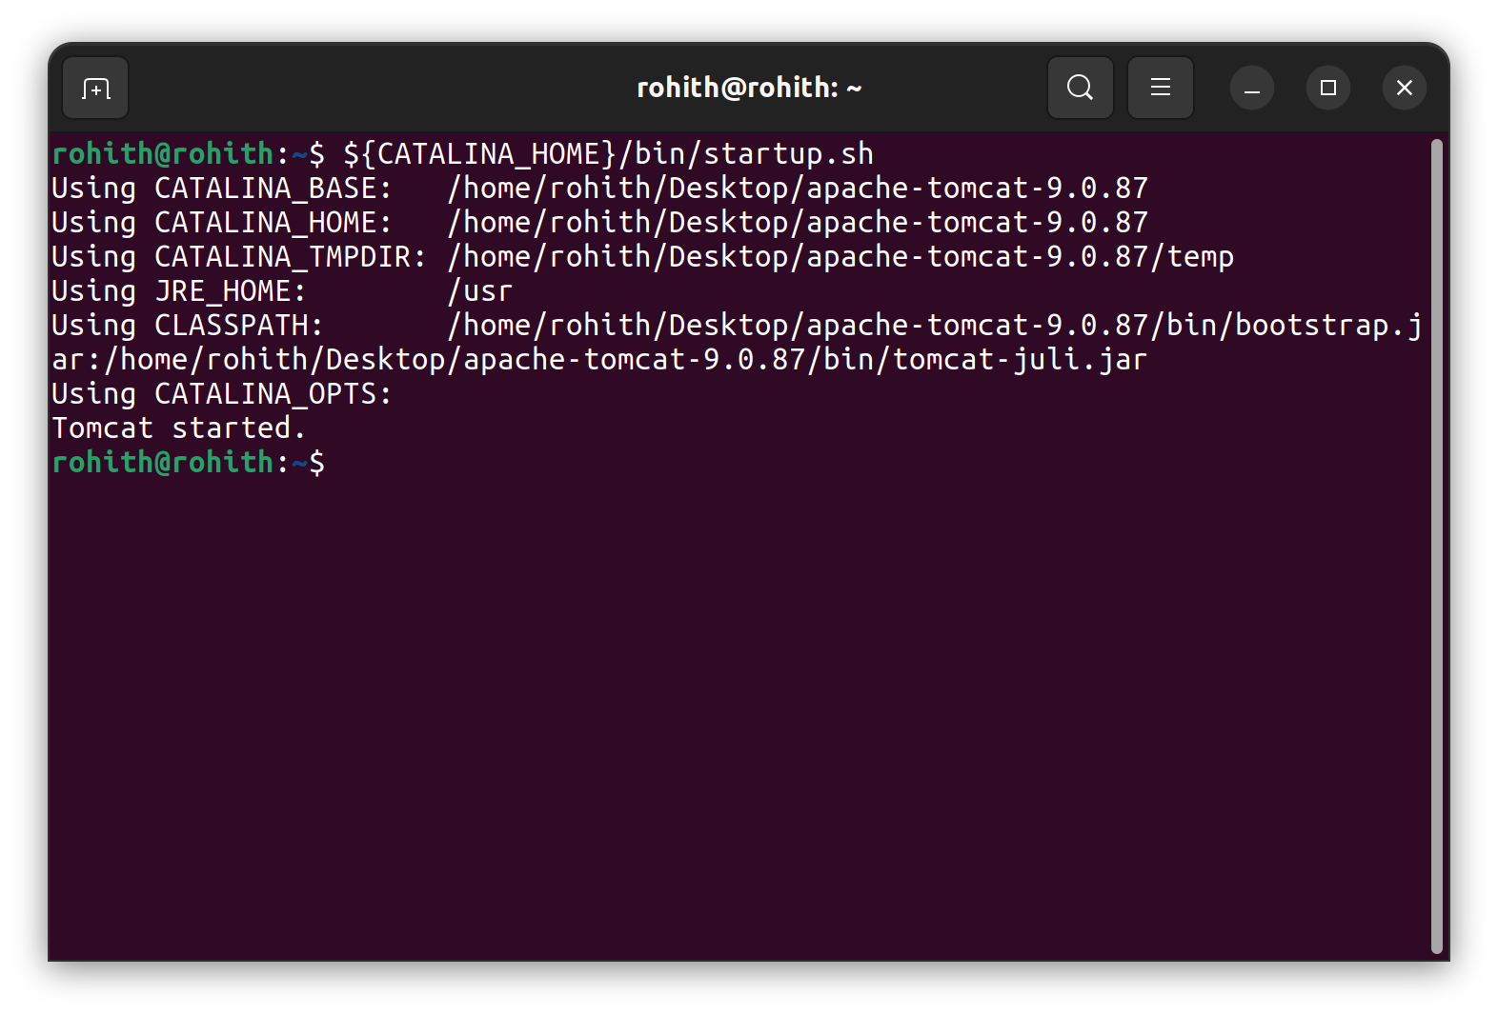
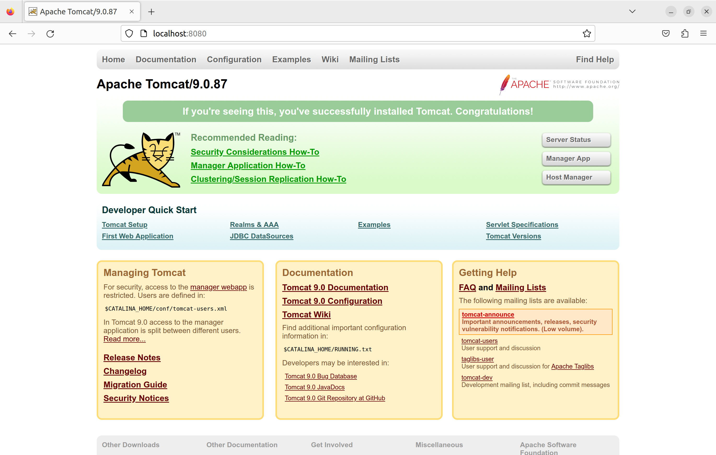
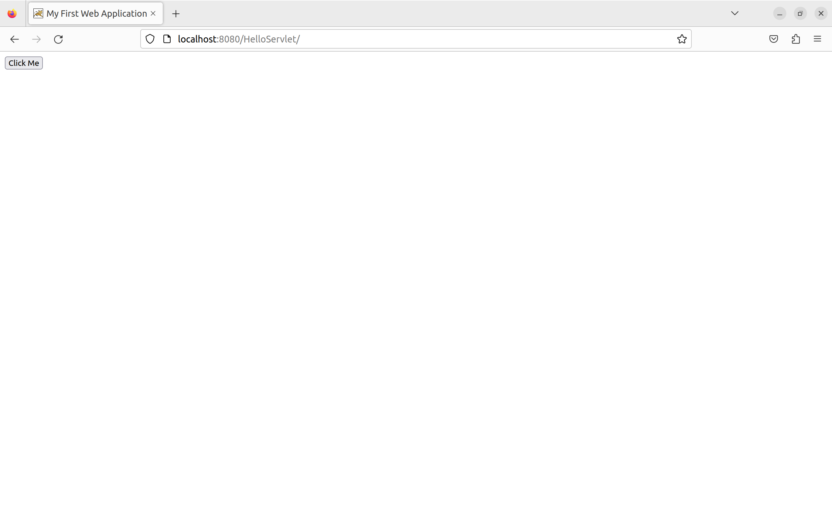
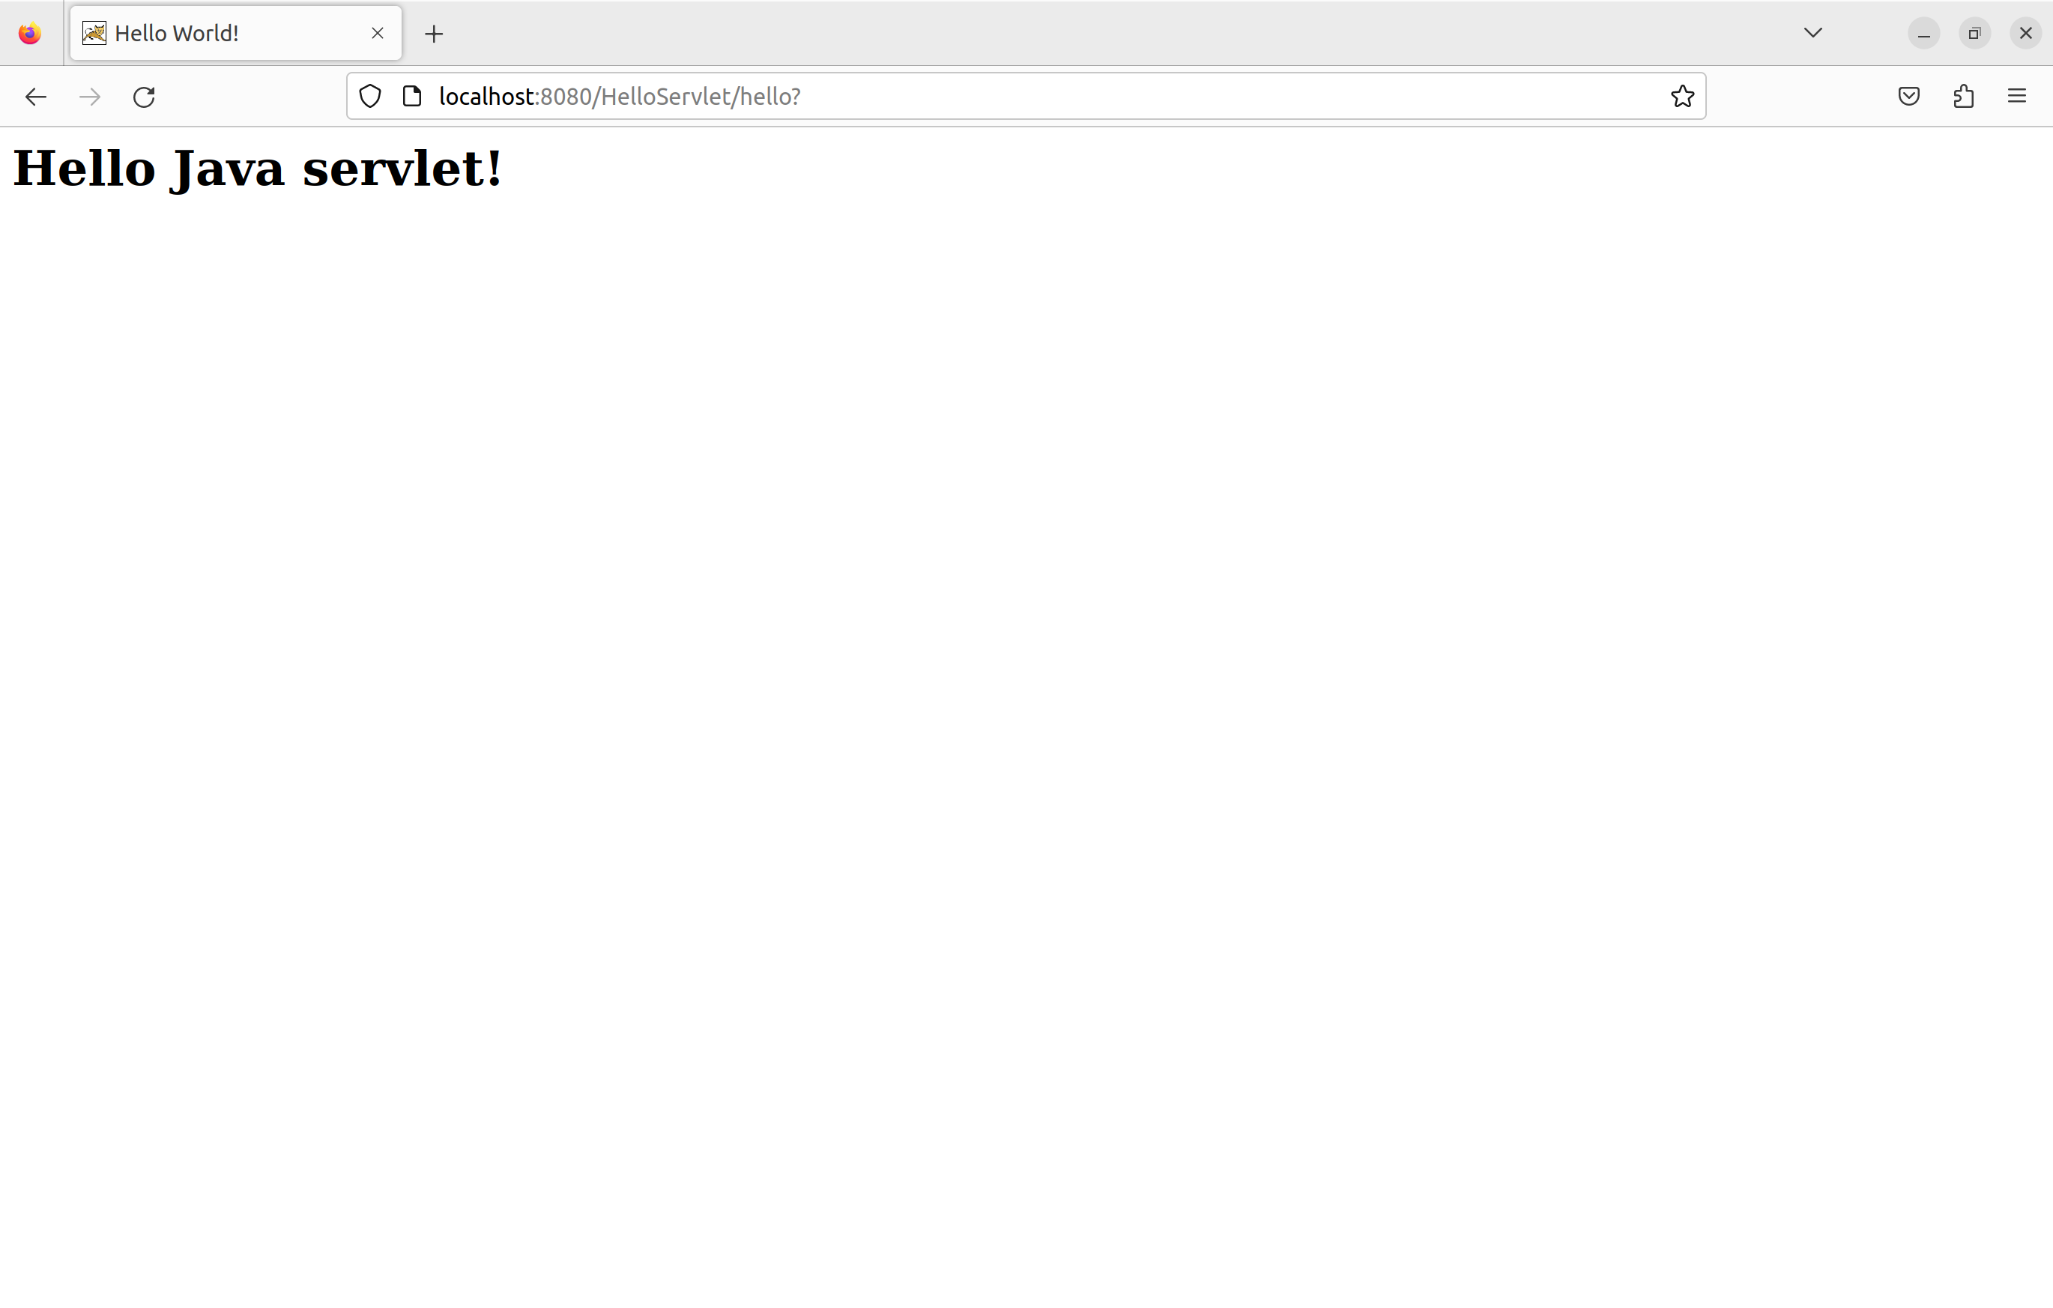
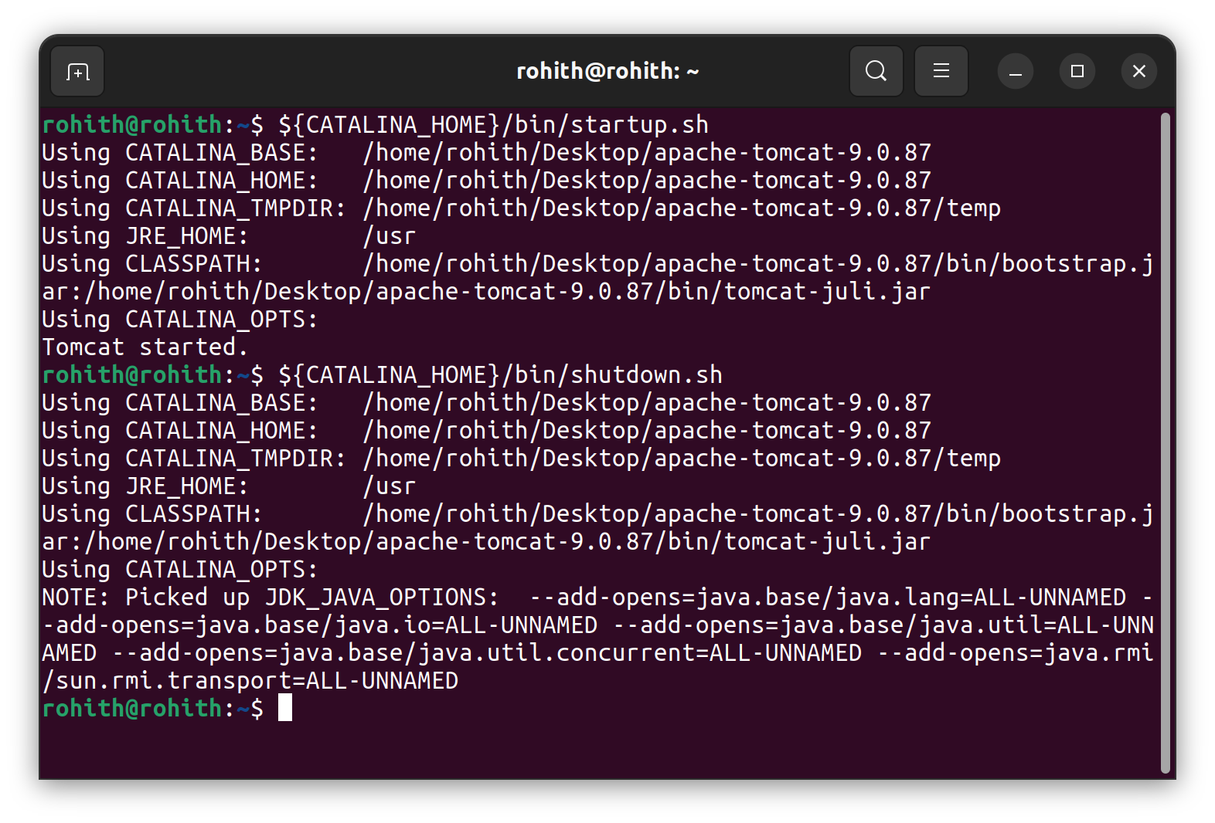
Learning Outcomes:

1. Understand the working of web server and its protocol in real time.
2. Developed a simple Client-Server web application.

